Hunkeler Innovationdays.2019
Parking order form

You have the opportunity to order parking tickets for CHF 60.00 / ticket. Following offer is available:

Premium exhibitor: 3 pieces
Standard exhibitor: 2 pieces
Remaining exhibitors: 1 piece

The parking spaces are located next to hall 2 (parking P21 and parking P2). The parking tickets are valid during the show. No additional ticket is needed during assembling and disassembling.

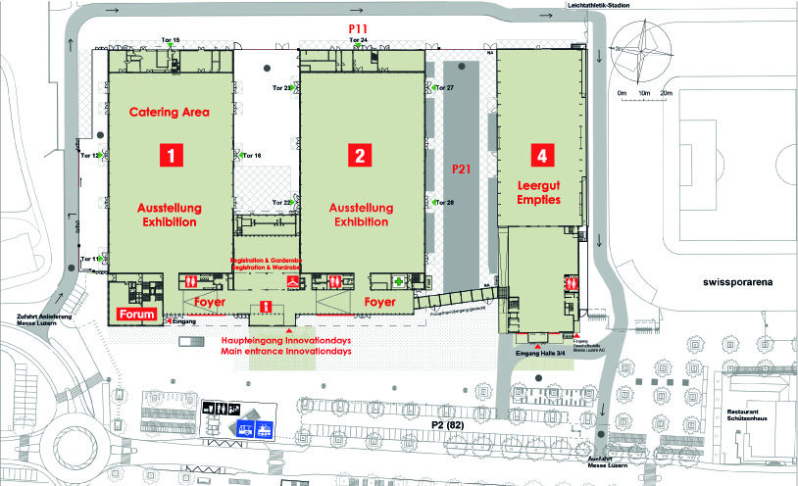

Exhibitor | Quantity | Your order | When possible, I will order following quantity
Premium exhibitor | 3 pieces | pieces | pieces
Standard exhibitor | 2 pieces | pieces | pieces
Remaining exhibitors | 1 piece | piece | pieces

Delivery address
Firma

Your contact
Address
City & Code
Country

Please return your order until Friday, 7th December to m.humm@hunkeler.ch Thank you!

